Invention, please provide in the word file
Format for submission patent details
Choose one: publication+ Examination process
Name of the Inventor | Nationality | Country of Residence | Address (Please include department name, University Address | Signature (specimen) | Gender  (M/F)
Chanchal Agrawal | Indian | India | Department of Data Science and Engineering, Manipal University Jaipur, India |  | F
Chirag Jotwani | Indian | India | Department of Computer Science and Engineering, Manipal University Jaipur, India |  | M
Dr. Krishna Kant Pandey | Indian | India | Cube No. 34, AB1, FB1, Department of Mechatronics Engineering, Manipal University Jaipur, India | 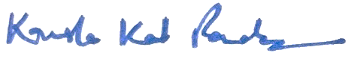 | M

Title of the Invention: An AI-Powered Automated Mineral Detection and Nutrient Infusion System.
Previous publication details, if published: Not published earlier.
- Abstract (150 words):
We have proposed an AI-powered hardware device for Automated Mineral Detection and Nutrient Infusion for rural as well as urban localities. The device has been incorporated with an Arduino Uno which functions as the real-time Input and Output controller and a Raspberry Pi 5 which works as the Central hub for Processing and Communication. The soil and environmental conditions are measured/monitored by a Sensory Array including Soil Moisture, pH, TDS, Ultrasonic, Temperature and Humidity Sensors. The Arduino collects and transmits data to the Raspberry Pi 5, executing a trained Random Forest AI model to determine precise irrigation and nutrient requirements. Relay-controlled pumps and solenoid valves are turned on to provide the ideal amounts of water and nutrients based on collected forecasts from sensory inputs. The low cost, robust, scalable and fully automated system improves agricultural productivity in both urban and rural farming scenarios. For visual plant analysis, it can also be integrated with a camera module as the future work.
Area of application (10-20 Words):
Urban gardening, automated irrigation and nutrient management, smart farming, precision agriculture, and agricultural IoT solutions.
- Background:
"AI Powered crop yield prediction and optimization" is the problem statement being addressed. Traditional farming practices need a lot of manual labour and frequently result in wasteful use of fertilizer and water. Although there are smart farming solutions available, they are frequently costly, proprietary, and inflexible for a variety of agricultural environments. By utilizing inexpensive, open-source components like Arduino and a modular design facilitating simple expansion, this invention gets around these restrictions. Precision agriculture is now affordable for both farmers and gardeners due to its capability to handle and automate resource management equipment’s using AI-powered system.
Detailed description:
A hardware-integrated device mineral detection and automated nutrient infusion in soil is the subject of the proposed invention. The system consists of two main components including an Arduino Uno which is responsible for handling real-time input/output operations and a Raspberry Pi 5 which acts as the central processing and communication hub. All the parts work together and create a closed-loop control system for Precision Agriculture.

a. Central Processing Units
- The primary computational core is the Raspberry Pi 5. It handles cloud connectivity, executes the AI-based nutrient prediction algorithm, processes data from the Arduino, and can be made to communicate with the user via a dashboard.
- All analog and digital sensor inputs are handled by the Arduino Uno, functioning as a real-time controller. It uses a variety of sensors to read environmental parameters and manages irrigation and nutrient management by controlling actuators like solenoid valves, and tiny water pumps. Serial communication (USB/Universal Asynchronous Receiver/Transmitter (UART)) is used to transfer data from the Arduino UNO to the Raspberry Pi.
b. Sensor Cluster
- Soil Moisture Sensor: measures the amount of water in the soil to identify when irrigation and nutrient diffusion is necessary.
- pH Sensor: Determines the acidity or alkalinity of the soil to evaluate the conditions for nutrient absorption
- TDS (Total Dissolved Solids) Sensor measures the amount of minerals present in the soil solution.
- Ultrasonic Sensor The water level in the reservoir or nutrient tank is measured using this.
- DHT11 Sensor: Tracks how humidity and temperature affect crop growth.
The Arduino Uno receives real-time data from these sensors, making up the hardware system's input layer.
c. System of Actuation
- Mini Water Pump(s): In charge of supplying the plants with water and nutrients, these pumps will be managed by the Arduino through relays.
- Solenoid valves: Will control tank fluid flow according to anticipated nutrient needs.
- The relay module will be serving as a bridge connecting high-power actuation devices (such as pumps and valves) to low-power Arduino outputs.
These components work together creating the output layer and automates the Mineral Detection and Nutrient Infusion.
d. Management of Power
- The system is powered by a continuous 5V DC supply for both Arduino Uno and Raspberry Pi 5.
- For continuous field operation, an optional solar charging circuit or Li-ion backup module can be included.
e. Interface for Communication
- Low-latency data transfer is ensured by the serial UART communication between the Raspberry Pi and Arduino. Additionally, the Raspberry Pi has Ethernet and Wi-Fi for remote monitoring and data logging to a cloud platform.
f. Function of the System (Operational Steps)
- Environmental and soil parameters are continuously measured by sensors.
- After reading the data and removing any noise, the Arduino Uno sends it to the Raspberry Pi.
- To forecast nutrient and irrigation needs, the Raspberry Pi uses an onboard artificial intelligence model called Random Forest to process the data.
- Control signals are returned to the Arduino based on predictions.
- To dispense the precise amount of water and nutrients, the Arduino will be turning on the appropriate pumps and valves.
- To maintain ideal soil conditions, the procedure has to be repeated in predetermined cycles.
With little assistance from humans, this hardware-driven control loop can guarantee effective use of fertilizer and water.
Hardware Components Summary Table:
Component | Model / Type | Role in System
Raspberry Pi 5 | Central Processor | AI Processing, cloud connectivity and data logging
Arduino Uno | Microcontroller | Real-time sensor data acquisition and actuator control
Soil Moisture Sensor | Capacitive type | Detects soil water level
pH Sensor | Analog probe | Measures soil acidity with the help of pH
TDS Sensor | Analog sensor | Monitors dissolved nutrients
DHT11 Sensor | Digital | Measures temperature and humidity of the environment
Ultrasonic Sensor | HC-SR04 | Detects height of the plant according to its growth stage
Mini Water Pump | 12V DC | Will dispense nutrient/water solution
Solenoid Valve | 12V DC | Will control flow from tanks
Relay Module | 5V | Will be interfacing Arduino with high-current devices
Power Supply | 12V/5V Regulated | Powers entire setup

- Experiments Details/Steps, Test results, Characterization Results:
The development and validation of the system were carried out in multiple hardware-centric stages, focusing on assembly, interfacing, calibration, and operational testing of all components.
First Step: Assembling Hardware
The core hardware system consisted of the physical integration of all sensing and actuation components.
- Sensor Integration: Using a breadboard and jumper connections, an Arduino Uno was interfaced with soil moisture, pH, TDS, ultrasonic, and DHT11 (temperature and humidity) sensors.
- Microcontroller–Processor Interfacing: A Raspberry Pi 5 is used as the primary processor for AI communication and computation tasks, and it is connected to an Arduino Uno.
- Actuator Setup: For safe switching, a 5V relay module was used to connect a 12V mini water pump and solenoid valve.
- Power System: A regulated 12V DC supply with onboard voltage regulation for 5V and 3.3V lines supplied power to the circuit.
This process validate the Raspberry Pi and Arduino's safe and secure data communication, voltage-level integrity, and physical compatibility.
Step 2: Validation of Signals and Circuit Testing
Every sensor is powered separately, and its output voltage or digital signals have been checked.
- Analog sensors (pH, TDS, and soil moisture) have been tested on the Arduino's analog input pins (A0–A3) using the Serial Monitor.
- The response rate and timing accuracy of digital sensors (DHT11 and ultrasonic) have been verified.
- Dummy loads have been used to test relay switching in order to verify isolation and Arduino control signal response.
Correct wiring, steady power delivery, and precise signal interpretation were all validated by successful readings.
Step 3: Environmental Testing and Sensor Calibration
To guarantee the accuracy of the data, calibration was done:
- Sensor output at 0%, 50%, and 100% moisture levels have been compared to calibrate the soil moisture sensor.
- pH Sensor: Linear calibration has been performed using standard buffer solutions (pH 4, 7, 9).
- TDS Sensor: Correlates sensor voltage with dissolved solids levels using known nutrient solutions.
- Ultrasonic Sensor: Provides precise tank-level readings within ±1 cm.
For field deployment, these calibrated values have been saved as reference baselines.
Step 4: Gathering and Analyzing Data
Following calibration, the Arduino started collecting data continuously by sending sensor readings to the Raspberry Pi via UART (Universal Asynchronous Receiver/Transmitter) communication.
- The data was processed in real-time by the Raspberry Pi 5 and saved in structured CSV format for later examination.
- To interpret sensor data and forecast nutrient and irrigation needs, the trained Random Forest AI model was run locally.
Step 5: Closed-Loop Testing and Automated Actuation
The Arduino received control feedback from the AI output and used it to activate the pumps and valves based on the soil requirement predictions.
- In response to anticipated soil requirements, the system effectively demonstrated automated water and nutrient solution dispensing.
- Measurements of response latency, pump flow rate, and relay activation time were made to verify hardware actuation and computation were in sync.
Step 6: Findings and Insights
- Under various environmental circumstances, all sensors produced consistent, repeatable readings.
- With a very small communication delay (less than 50 ms), data transfer between the Arduino and Raspberry Pi was dependable.
- According to the AI model's predictions, the automated actuation delivered water and nutrients with a precision of ±5%.
- After operating continuously for more than eight hours, the hardware showed resilience.

- Salient Features supporting the system:
- An AI-Powered Automated Mineral Detection and Nutrient Infusion System consist of a Raspberry Pi 5 which acts as the Central hub for processing and cloud communication, has sophisticated computation and an Arduino Uno responsible for real-time sensor data collection.
- The Arduino Uno is connected with a sensory array consisting of Soil Moisture, TDS, pH, Ultrasonic, DHT11 sensors. All these sensors are responsible for providing continuous and precise environmental and soil conditions.
- The Arduino-RPi interface provides a smooth data transfer between the sensory array, processing and actuation layers with the help of a serial UART communication. Arduino takes care of the control of pumps, valves and relays while the RPi works as the master node taking care of the data analytics.
- The system has automated actuation mechanism, using solenoid valves and relay-driven control circuits to run 5V DC pumps and in this way it looks after the automated water and nutrient infusion with the help of AI-generated predictions without the need for humans to intervene.
- The system has a scalable and modular hardware design as the sensors, actuators and controllers are all built as different hardware blocks and can be easily modified, maintained and integrated with other things which may include a solar panel or even a camera module for plant health monitoring or plant leaf disease detection system.
- The continuous 5V DC power supply is responsible for a stable power and safety management system guaranteeing a secure and steady operation in the field of agriculture.
- The Raspberry Pi 5 supports both local and cloud-based operation and allows for the logging of data and remote monitoring.
- The system provides a sustainable operation by ensuring energy-efficient and environment friendly agricultural management. It provides only the required water and nutrients to the plants.

- Advantages of the Model:
- Efficiency and Sustainability: It maximizes fertilizer and water use, reducing waste and advancing sustainable agriculture.
- Increased Yield: Healthy plants and possibly higher crop yields are the result of timely and accurate nutrient delivery.
- Less Labor: The fully automated procedure drastically cuts down on the amount of time, effort, and manual intervention needed for plant maintenance.
- Scalability and Accessibility: It is an affordable option and can be used in both expansive agricultural fields and tiny urban gardens.
- Climate Adaptation: Provides farmers with a clever, self-sustaining system to help them adjust to climate variability.
- Unique technical points:
- Hybrid Dual-Processor Architecture: The system uses a special composite of the Raspberry Pi 5 and Arduino Uno, with the Raspberry Pi to handle high-level data processing, AI integration, and cloud communication, and the Arduino handling real-time sensor readings and actuator control through the relay modules. Both responsiveness and computational efficiency are guaranteed by this hybrid control architecture.
- Advanced Multi-Parameter Soil Requirement Analysis Hardware: To allow for thorough soil characterization, the model consists of a wide range of sensors, including pH, TDS, Soil Moisture, DHT11 and Ultrasonic sensors. Beyond the single-variable moisture sensing, periodic and manual irrigation techniques employed in traditional systems, this hardware-level integration enables accurate correlation between several soil parameters.
- Hardware-Implemented Predictive Intelligence: The Random Forest classification and regression model of the system interprets real-time data streams from the Arduino directly on the Raspberry Pi 5 hardware. This enables on-device intelligence for instantaneous actuation decisions and removes reliance on cloud-only computation.
- A fully automated closed-loop control mechanism creates a self-regulating hardware feedback loop. Sensors, AI on a Raspberry Pi, and Arduino-driven pumps and valves all work in constant synchronization to collect data. Without human input, this closed-loop control guarantees automatic nutrient delivery and irrigation.
- Dynamic Crop Profile Synchronisation: The device's modular software–hardware interface allows it to support AI-based plant profiles modifying hardware actuation parameters (such as pump duration, valve timing, and nutrient ratio) in accordance with particular crop needs, improving adaptability in a variety of agricultural scenarios.

- Drawings:
- Hardware Block Diagram of AI-Powered Mineral Detection and Nutrient Infusion System
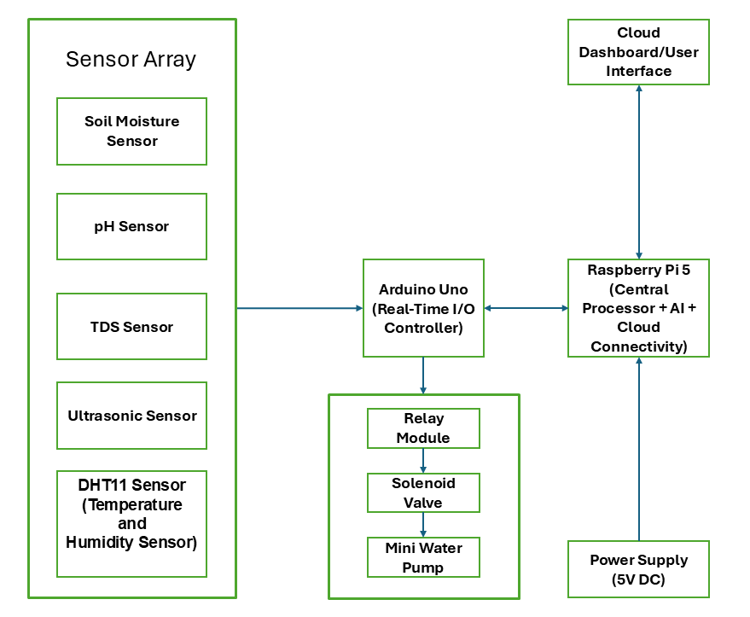
Figure. 1: Block Diagram showing interconnection of sensors, controllers, and actuators forming the automated mineral detection and nutrient infusion system

- Process flowchart illustrating the data flow from sensors to the AI model and finally to the actuators (pumps/valves).

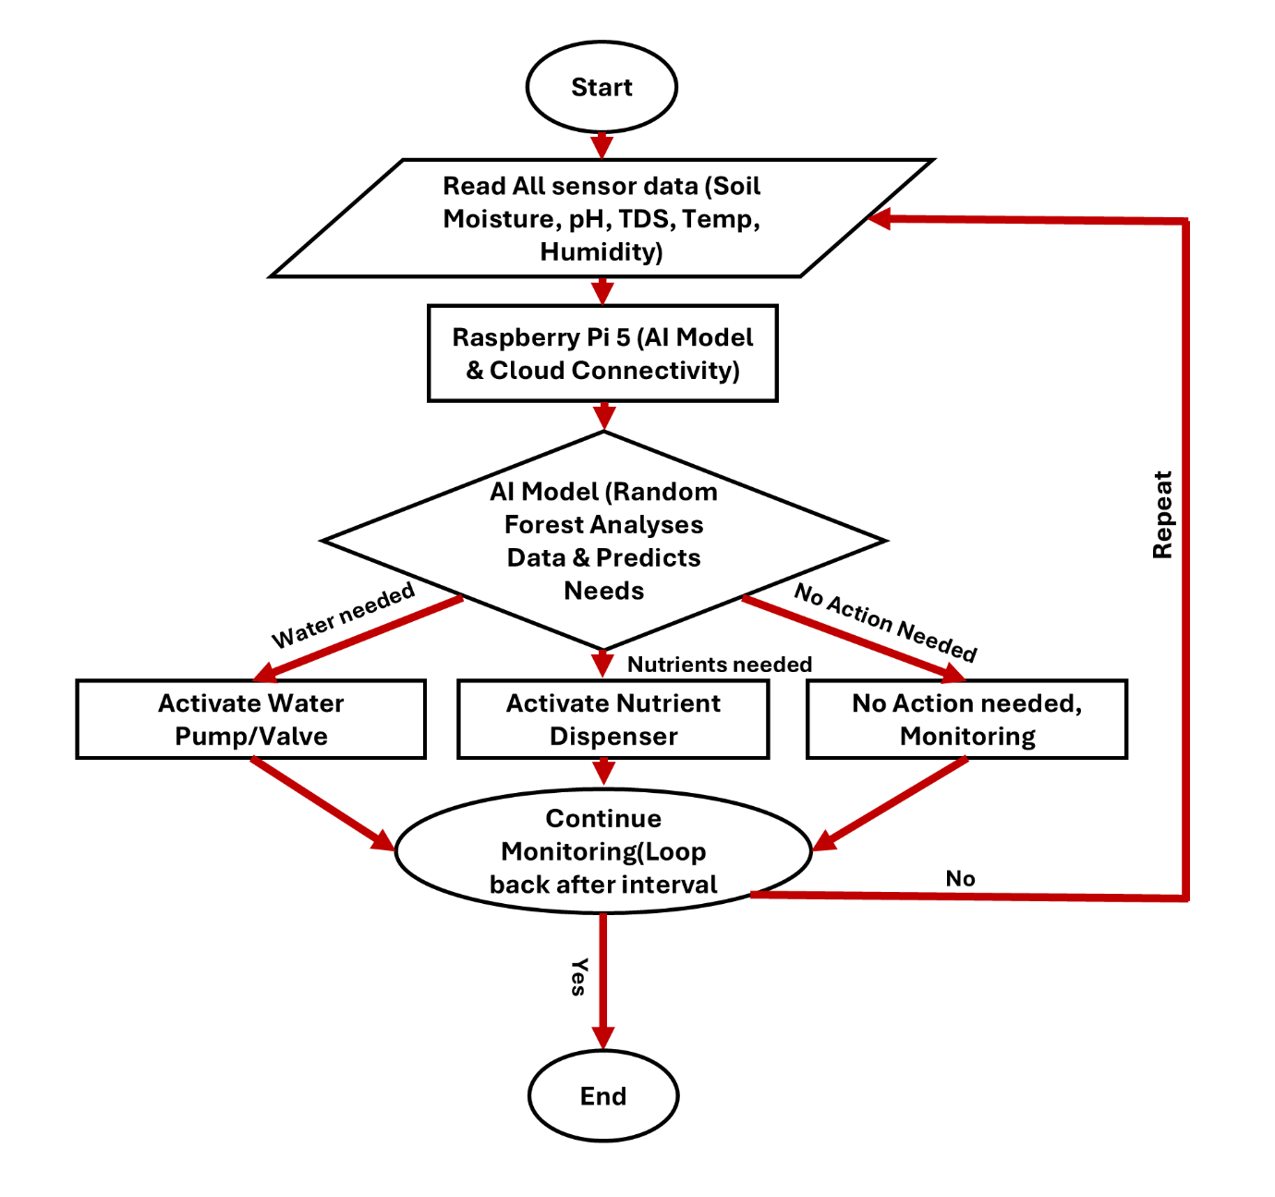
Figure. 2: Flow chart of data flow from sensors to the AI model and finally to the actuators (pumps/valves)

- System architecture
Figure. 3: System Architecture

- Planned Enhancement diagram showing the interconnection of the Arduino Uno, Raspberry Pi 5, various sensors, and the mini water pump.

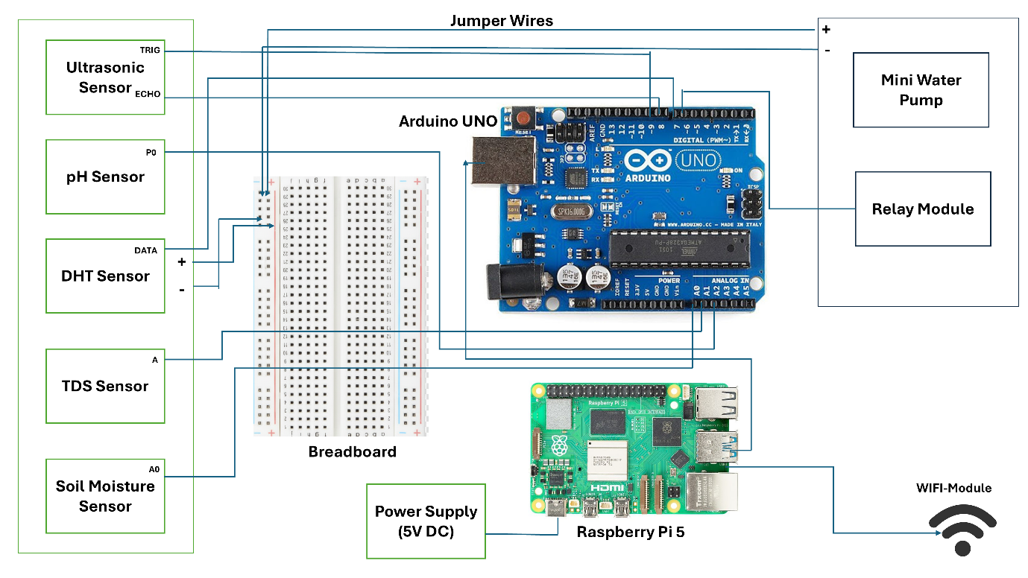
Figure. 4: Planned Enhancements

